CPE 301 Group 46 Semester Project

Nicholas Moulos

Karl Gudino

Joseph Mario Villa

**Overview of System:**

The system we designed functions as a swamp cooler. Typical swamp coolers function by blowing a fan over a water soaked filter; typically cold water. Our system functions like that, but without the filter. Our water sensor will read a water level, while our temperature/humidity sensor will give us a temperature as well as humidity reading. Once the humidity and temperature reach a certain threshold, our system will turn the fan on.

**Control:**

* Our system has one potentiometer that controls the brightness of our LCD screen
* Our system has one button that turns the system on and off

**Display:**

* Our system consists of 4 LEDs and one LCD
* The yellow LED turns on when the system is idling
* The green LED turns on when the system is running
* The blue LED turns on when the system has reached the proper temp and humidity threshold to activate the fan (77 degrees F)
* The red LED turns on when the water level is too low
* The LCD screen displays the temperature and humidity, as well as the idle message, and the error message

**Motors:**

* The system has 2 motors. The fan motor as well as the step motor
* The fan functions as any fan would
* The step motor functions as a directional vent; simulating the fan direction of the swamp cooler

**Sensors:**

* Our system has 2 sensors
* A water level sensor, that measures the water level and sends a signal to the ADC, where it is then converted to a value on the LCD screen
* A Temperature/humidity sensor reads the temperature and humidity in the operating area, and sends a signal to the LCD screen.

**Pictures of System:**

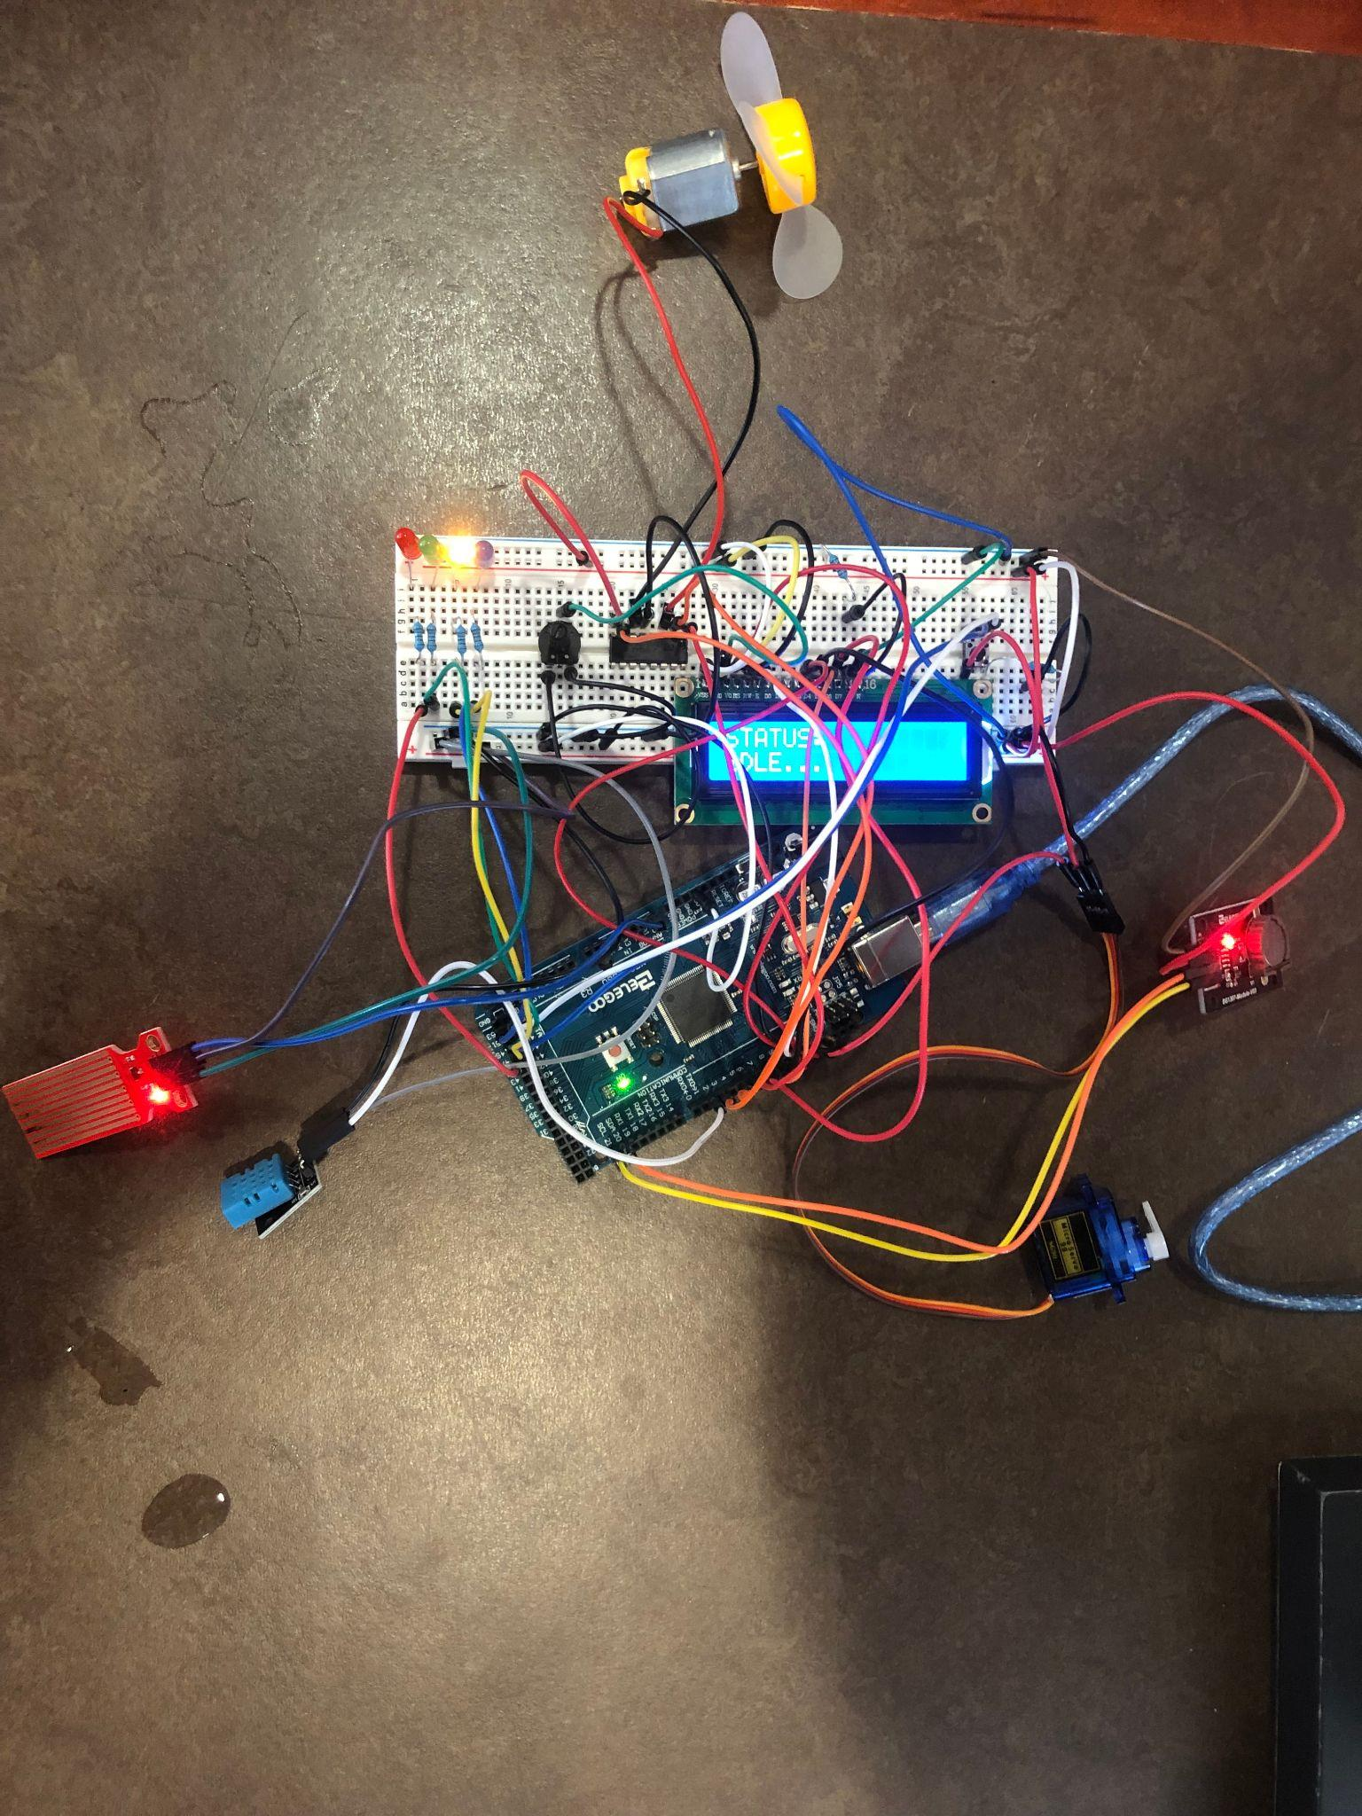

**Figure 1: Picture of the system idling**

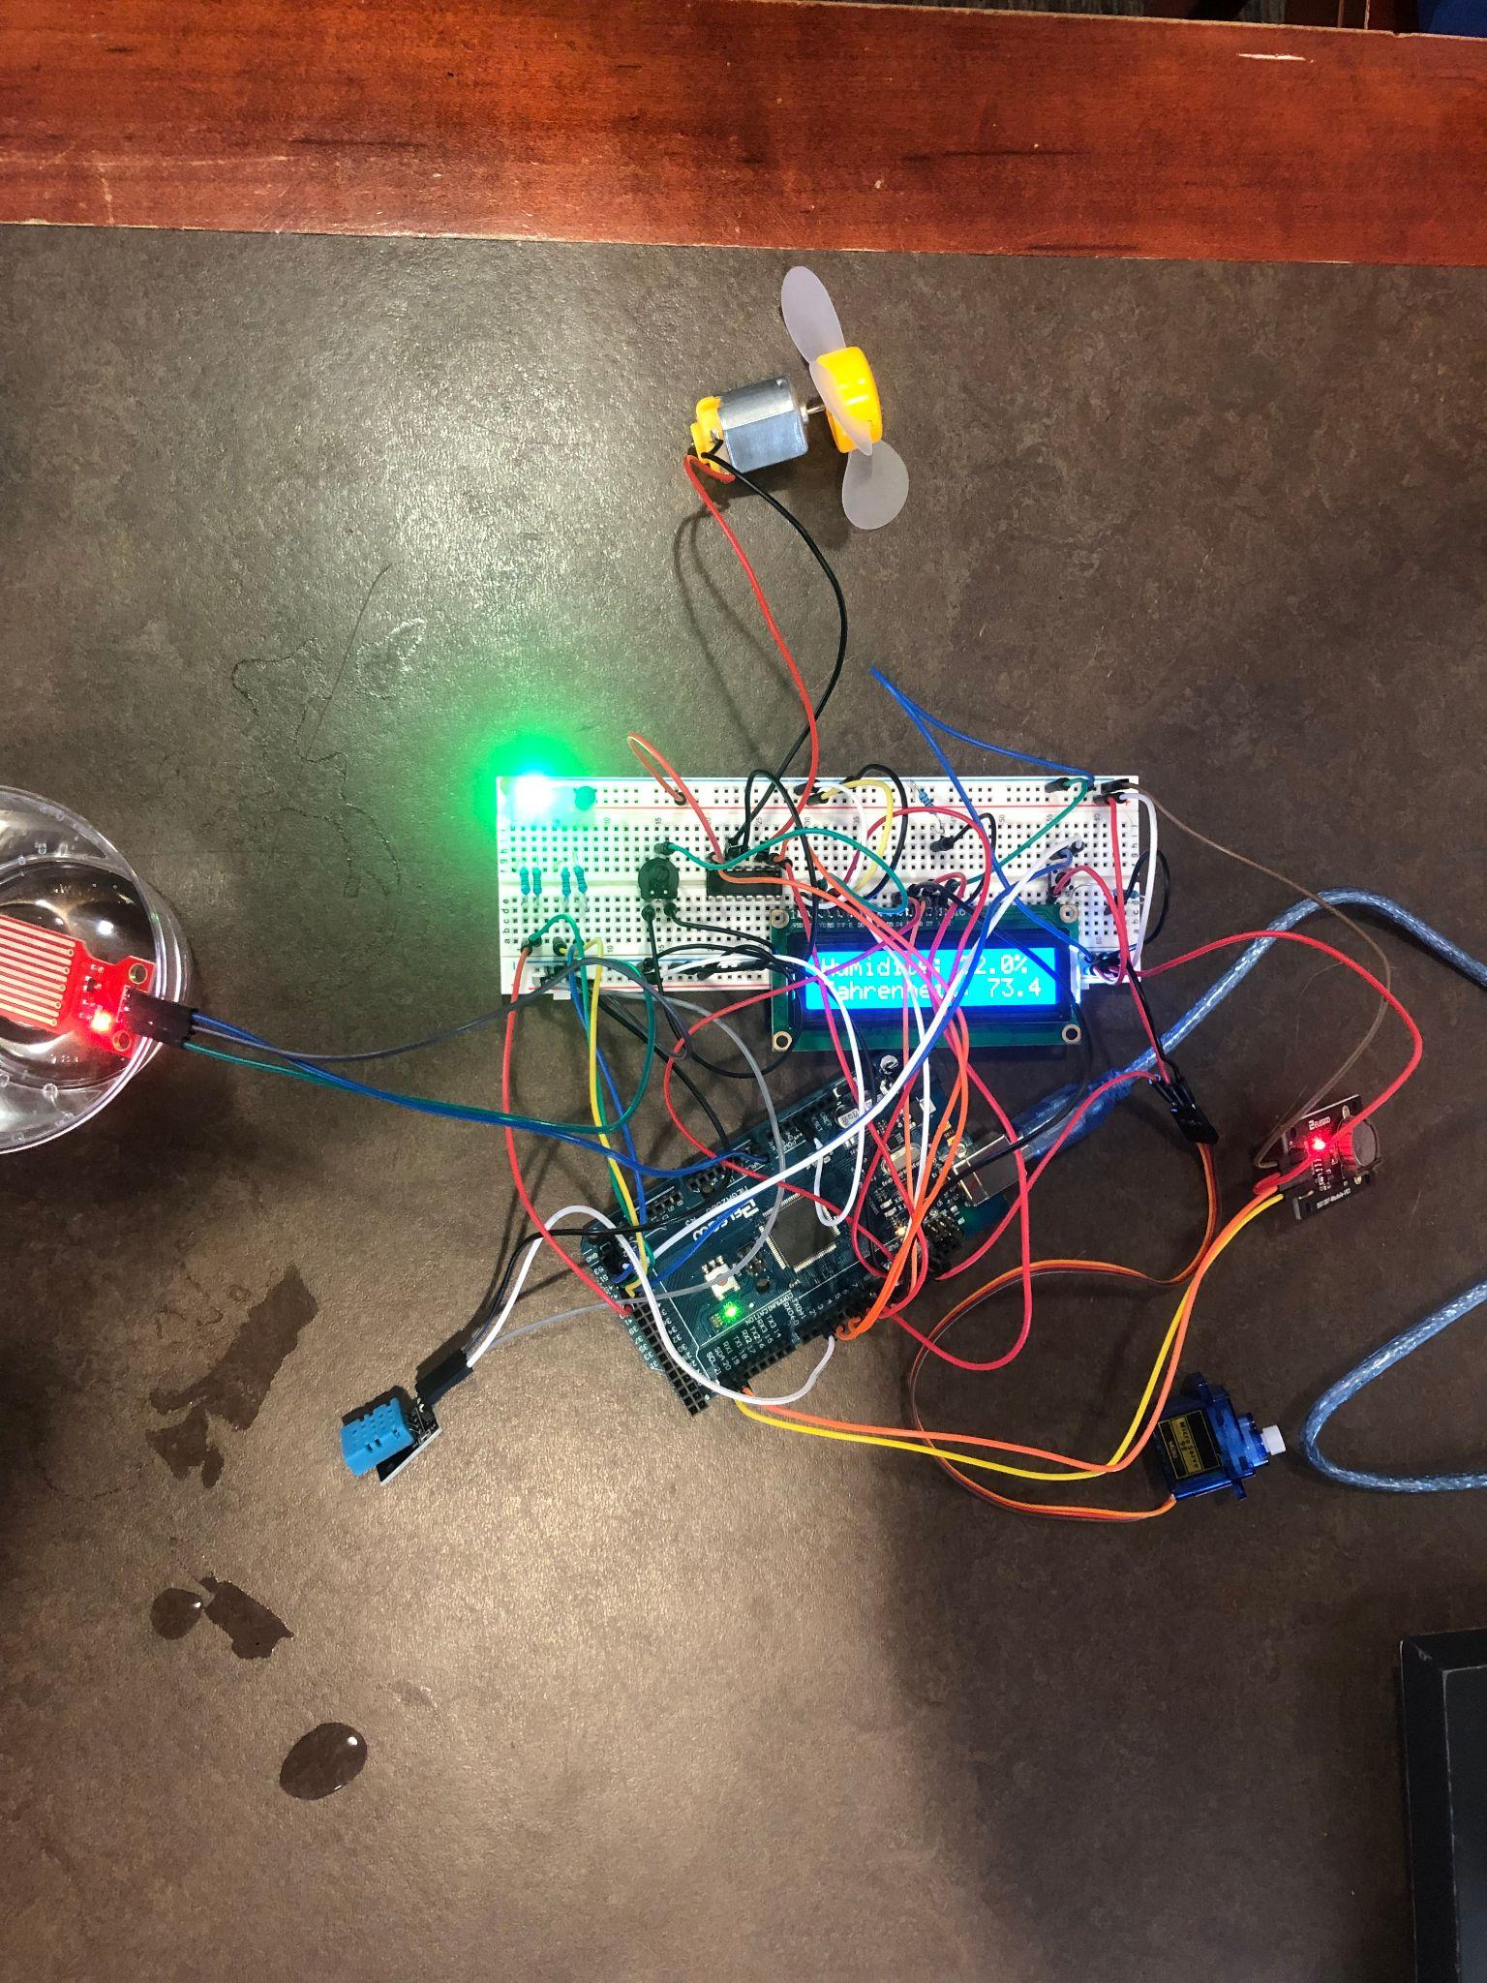

**Figure 2: Picture of the system running**

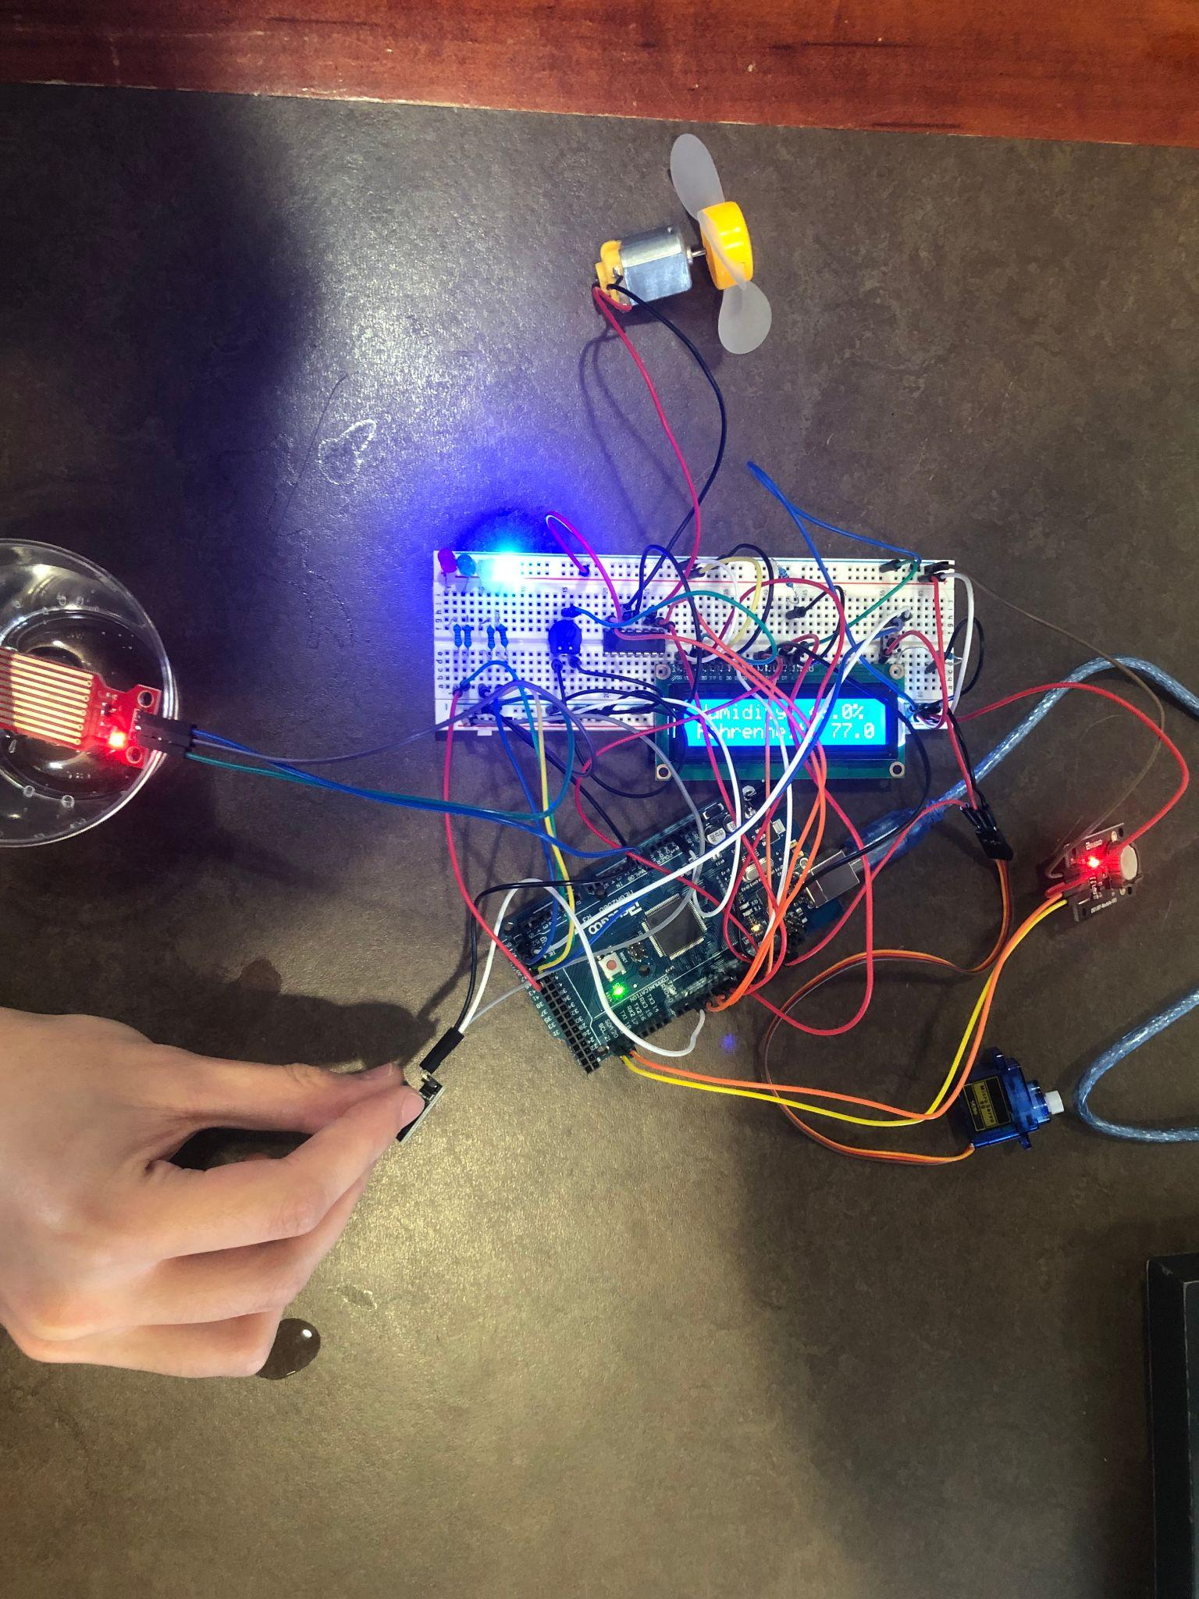

**Figure 3: Picture of the system after temperature and humidity threshold was met**

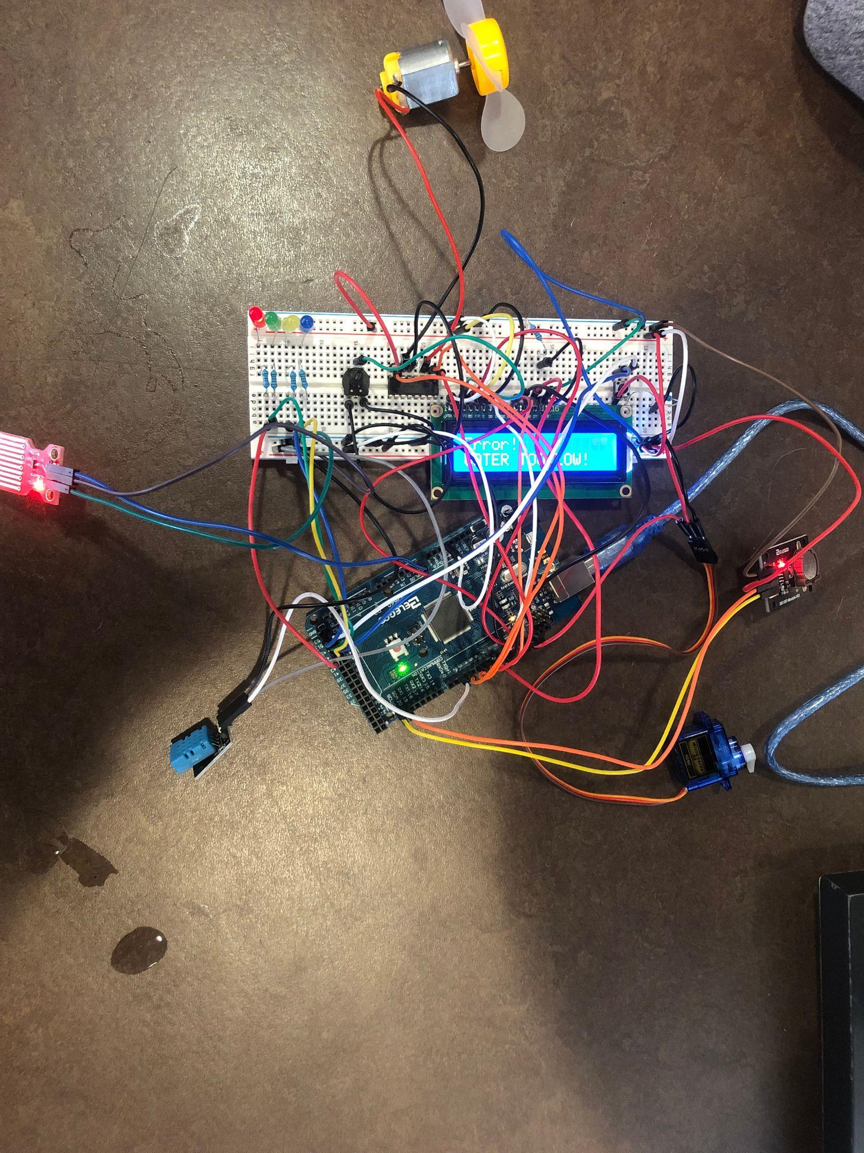

**Figure 4: Picture of the system when water level is too low and error message shows**

**Links:**

[CPE 301 Spring 2022 Project](https://www.youtube.com/watch?v=2XlgAe_pgPg)

[**https://github.com/karl-gn/CPE-301**](https://github.com/karl-gn/CPE-301)